1. Agenda:
   1. Will discuss the various properties to configure circuit/switch.
2. Configurations:
3. 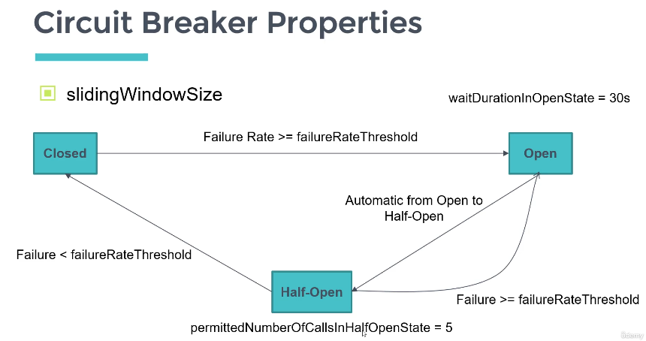
   1. 
      1. How many last calls to be considered to make a decision when a circuit should go from closed to open.
      2. **For example**:   
         If student service is called address service and call rate is 1000/sec.   
         If window size is 100, then it will check last 100 so from 901 to 1000. Now in next few seconds, 100 more calls are made, so total calls are 1100 so again it will check last 100 calls.
      3. Numeric value
   2. 
      1. Percentage value.
      2. For example: failureRateThreshold=50.  
         Our slidingWindowSize=100 🡺 So last 100 calls will be considered.  
         failureRateThreshold=50  
         Suppose, 60 of 100 calls are getting failed.  
         So, Failure Rate = 60%, failureRateThreshold=50% which implies failureRate >= failureRateThreshold so, circuit breaker will go into OPEN state.
      3. :
         1. We can’t be in OPEN state for long time.
         2. This property defines the time which when expires, the circuit will come into HALF_OPEN state.
         3. Actually, giving time to a service to recover itself.
      4. 
         1. We know that in HALF_OPEN state, only limited calls are allowed.
         2. permittedNumberOfCallsInHalfOpenState=5 🡸 Only 5 calls are allowed.
         3. Again it will check 🡺  as we discussed in failureRateThreshold and the circuit will go in OPEN state and if  then circuit will go into CLOSED.